Day 8 – 2 Apr 2024

Spring Framework or Adv Spring Framework

40 hours training

Spring boot, Spring reactive modules, spring web client, spring with hibernate.

Spring transaction management, spring security etc.

<https://start.spring.io/>

Eureka Server

Starter 🡪 Eureka Server and Web Starter

Port number 8761

application.properties

spring.application.name=Eureka-Server

server.port=8761

eureka.client.register-with-eureka=false

eureka.client.fetch-registry=false

Account micro service

Account table -🡪 accno(pk), name, emailid(unique), amount etc

Account entity

AccountRepository

AccountService

AccountController

Create account, findAllAccount, findBalance(accno),findAccnoUsingEmailId() etc

Database 🡪 mysql 🡪 db name account_db

9191

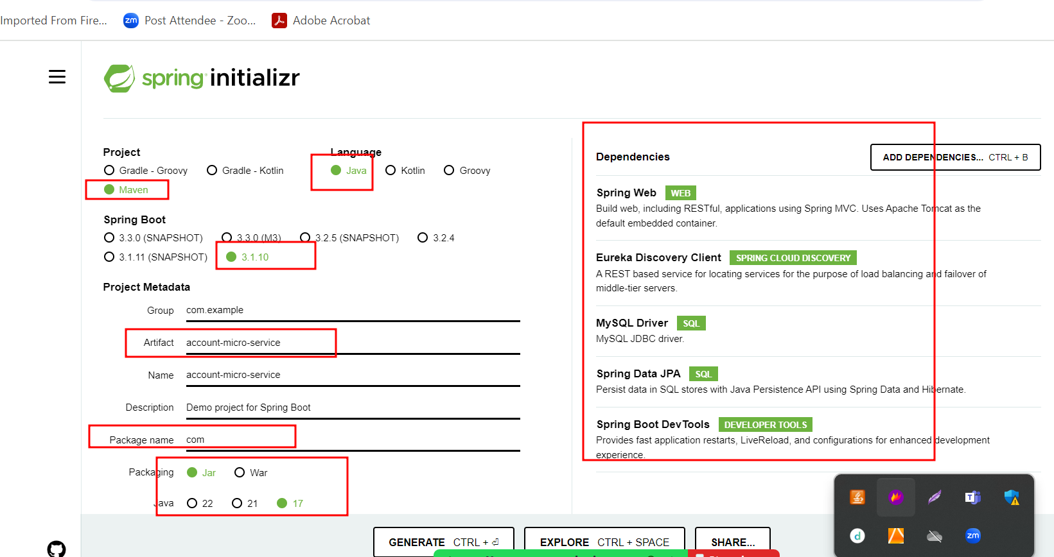

Paypal – service

Paypal table 🡪emailid(PK), accno etc

Paypal entity class

Paypal repository

Paypal service

Paycontroller

Pay pal account create, findBalance when we can emaidid find balance

9292

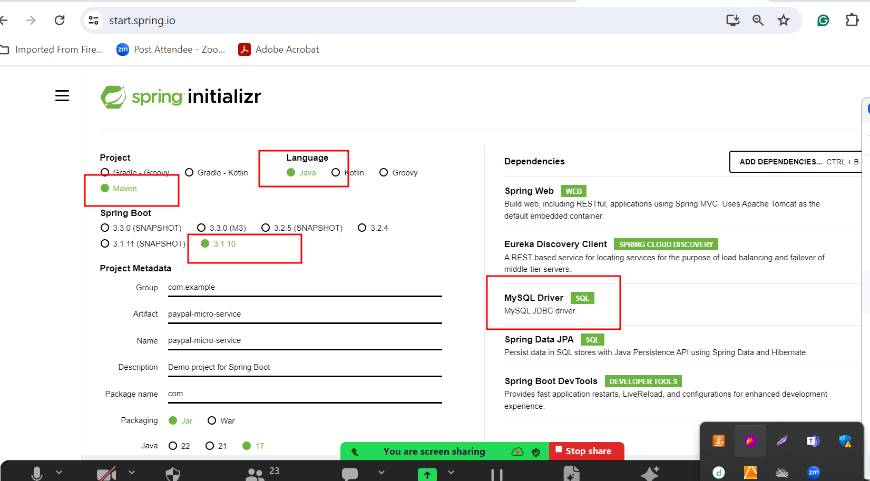

RestTemplate : This API help use to call Rest API develop using same language or different language.

WebClient : Reactive Rest API

Reactive Programming : is a programming paradigm where we focus on developing asynchronous and non – blocking application in an even – driven architecture.

1st line

2nd line

3rd line

Ajax : Asynchronous JavaScript and XML.

XMLHttpRequest pre defined object

If communication is as a synchronous

Send req 1, req 2, req 3 , req 4

If communication is as a asynchronous

Req1

Req2

Req3

Req4

Client Server

It is a like a multi threading

Thread can be block.

By default java is multi threaded

When we deploy any application in java related server. By default they are multi threaded.

Number of client means number of thread.

But thread can be block.

This server can concurrently handle 100 client.

Thread pooling

Number client increase means after 100 if any client send the request our server can’t response. So our request get blocked.

Using Reactive programming in backend technologies we can achieve asynchronous as well as non blocking mechanism

RxJS (Reactive Programming )

To do reactive programming in java we need to depends upon third party library or dependencies.

1. Reactor
2. RxJava
3. Akka

Mono : return 0 or 1

Flux : many

Data can be any type like integer, float, char,String, user defined object.